**WORKFLOW Connection Guide Through TONE**



## 

In some cases, we use LANGFLOW software to connect the agent with an external FLOW from LANGFLOW. If we choose to connect the Interactive with TONE, there is no need to use the other components.

## **How do we make the connection?**

First, we'll enter the Agents tab, select the desired agent, and click Manage.

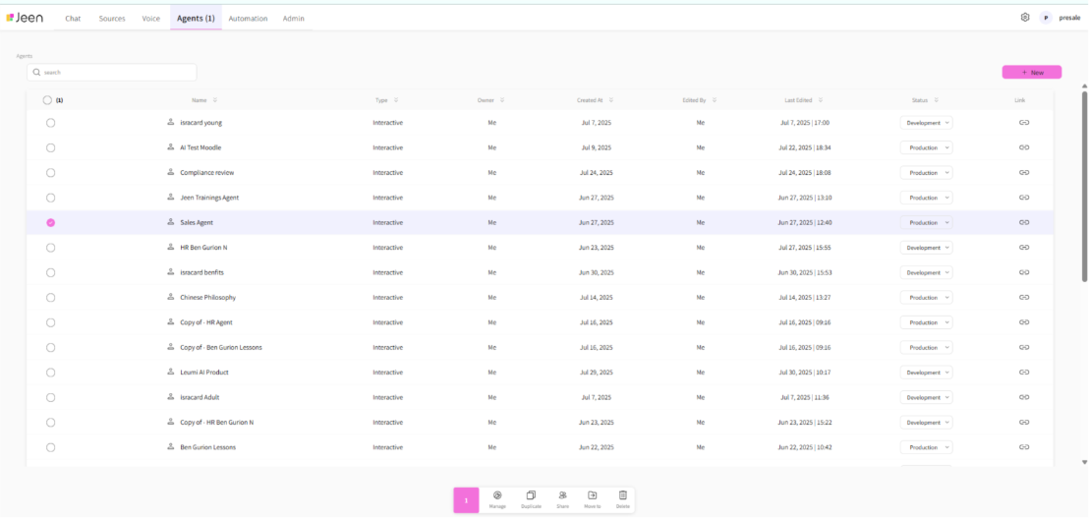

We'll click on the agent's TONE component and select the WORKFLOW model.

תמונה שמכילה טקסט, קו, צילום מסך, גופן

תוכן בינה מלאכותית גנרטיבית עשוי להיות שגוי.

Then we need to choose the desired flow.

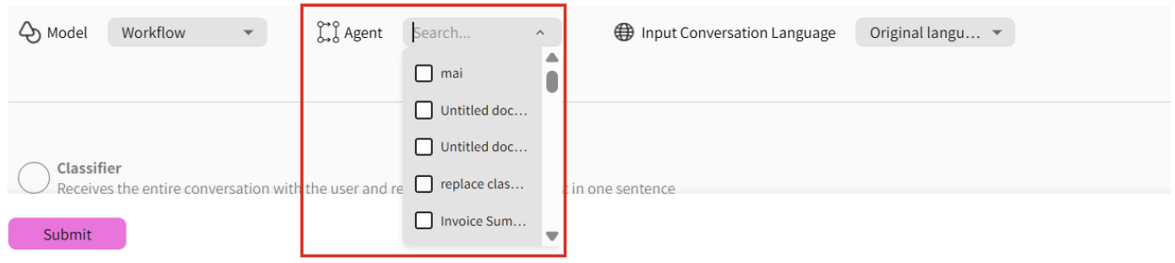

This section decides whether the flow will receive the conversation in its original language or receive it translated to English. Our recommendation is to leave this as default and keep it in the original language.